Article written for online magazine on www.righands.com (launched in 2011, the website closed in late 2018).

Russian Arctic Platform Starts Production, Will Produce 120,000 BPD!
by John Pendleton | Monday, April 21, 2014

Last October 30 "activists" from Greenpeace attempted to storm Russia's massive Prirazlomnaya platform, an Arctic offshore oilfield located in the Pechora Sea, south of Novaya Zemlya, Russia. The rig workers blasted them with large water-hoses and the Russian Coast Guard flipped their inflatable boats. Eventually they were all taken into custody and charged with Piracy.
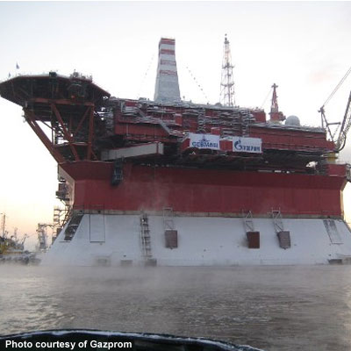
They got the message and haven't been back since.
On Thursday, April 18th, Russian President Vladimir Putin announced that the Prirazlomnaya platform has begun production and has now shipped its first oil. A tanker approached the platform, received its load of 490,000 barrels of crude and departed without incident, headed for a refinery.
The Prirazlomnoye field, which is about 40 miles off Russia's northernmost coast, is believed to hold more than 500 million barrels of oil and is expected to be producing 120,000 barrels per day by 2020.
The platform's well heads are located on the decks, instead of being on the seafloor as was the case with the Deepwater Horizon. There are two icebreakers permanently stationed near the platform at all times, ready to crush pack ice so any spills can be quickly cleaned up. When the oil is transferred to container ships, the booms have automatic sensor mechanisms that would cut off the flow of crude immediately if the ship starts to drift away from the platform while loading. A protective caisson surrounds the base of the platform by keeping floating ice at bay.
Russia is the world's largest producer of crude (followed by Saudi Arabia and the United States) but needs to continue bringing new fields on-line as older fields become depleted. This field, discovered back in 1989, will help close that gap.
………………………………………………………………………
Archived version available here: https://web.archive.org/web/20150317043519/http://www.righands.com/news/news-detail/russian-arctic-platform-starts-production-will-produce-120-000-bpd-606

